**Lesson3 APP12:**

**Delete an S3 Bucket**

**Selecting the S3 bucket you want to delete:**

* Choose the bucket

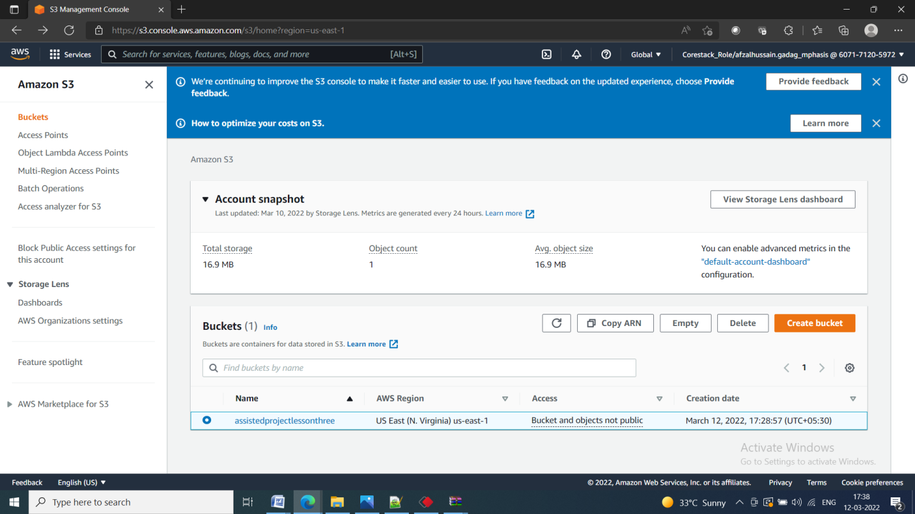

**Deleting the bucket:**

